The Metasploit Framework is the most commonly-used framework for hackers worldwide.

* Exploit any windows OS using Metasploit.

**Note: The link to the video in google drive is in the end of the file**

**Answer: first we check the ip address for the OS 7 using “netdiscover”**

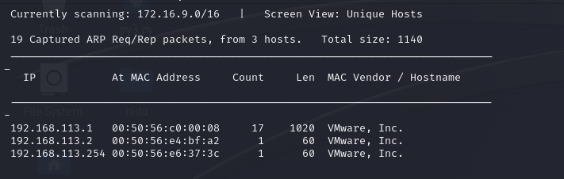

**Then we use the “nmap” fuction to check on the IP address and get its info along the ports and its scripts.**

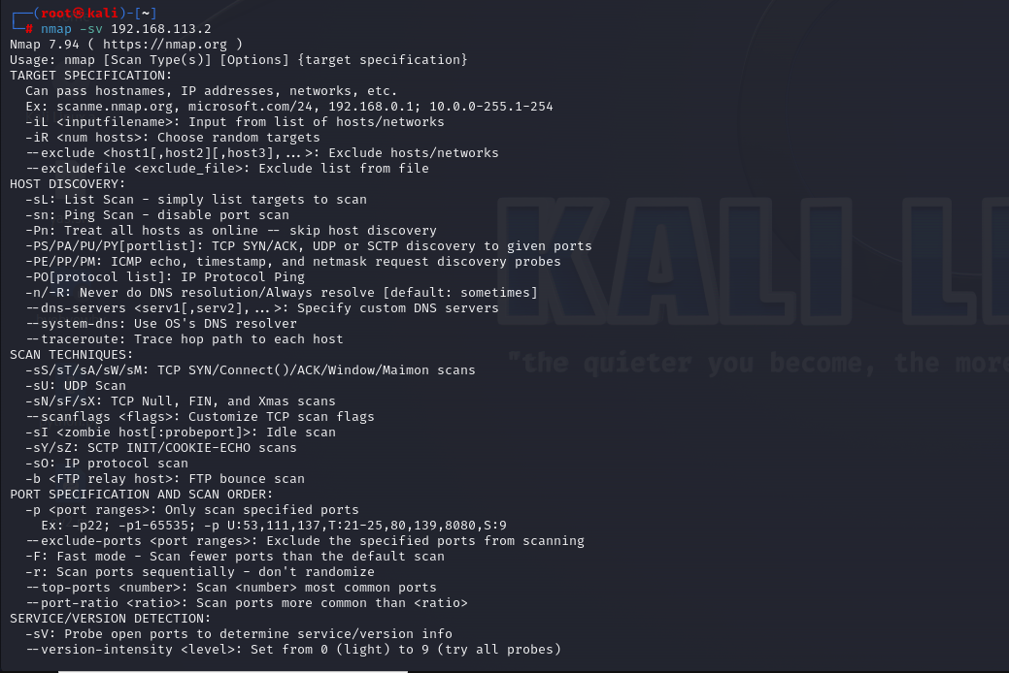

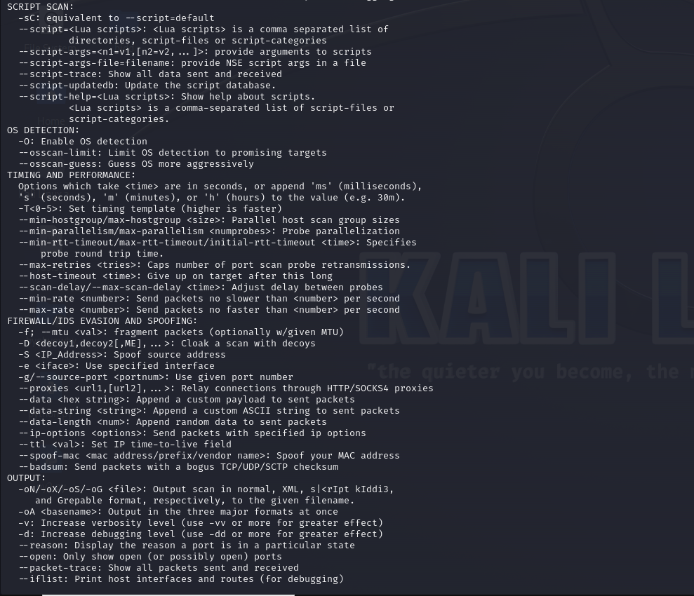

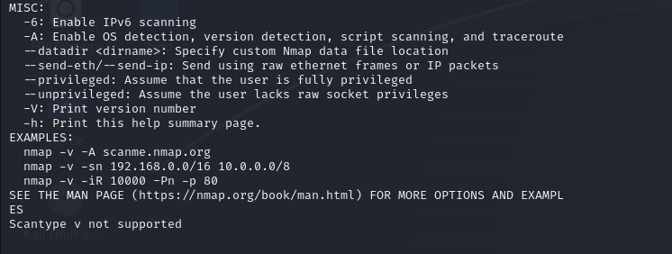

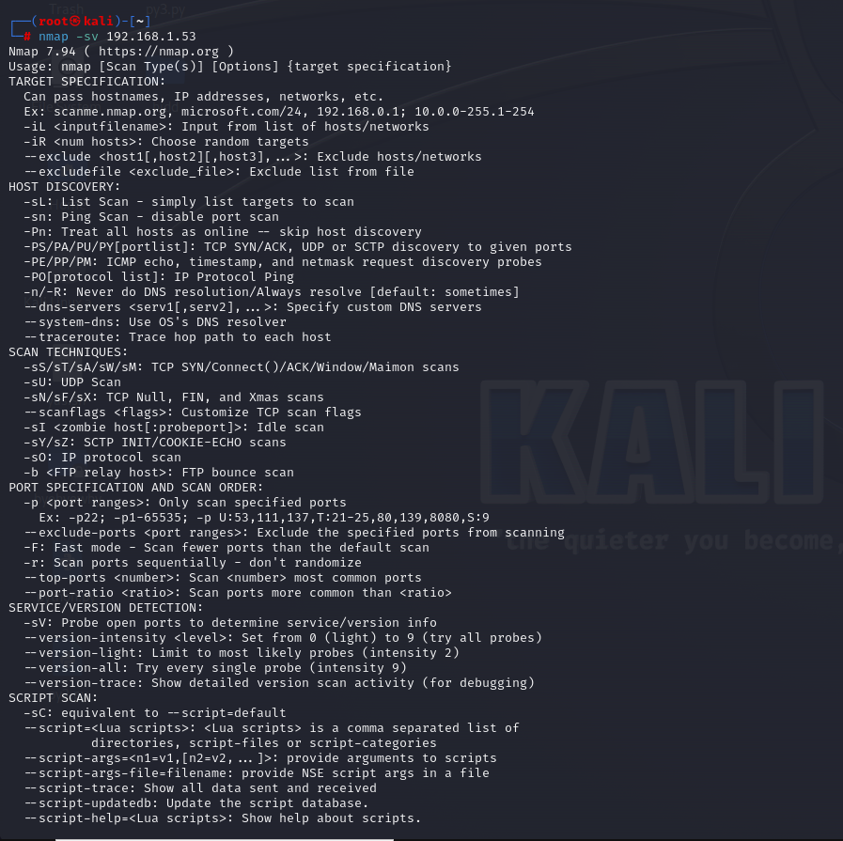

**After that we have the “nmap – Script smb-vuln” function to check using the script or the smv vulnerabilities for the given ip and find its ports and tcp which are active.** 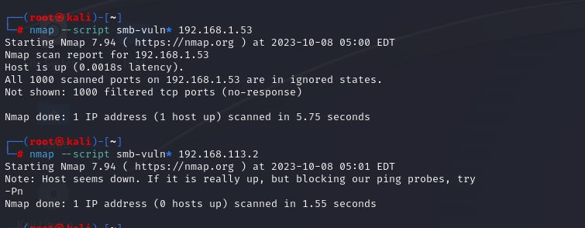

**Then we open the metasploit frame work using “msfconsole”.**

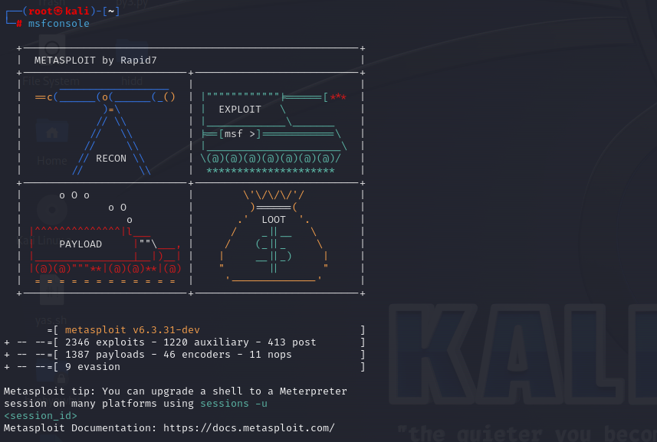

**Then we search for the ms17 function to see if its usable or not, now the ms17-010 function is what intelligence agencies use to gain access to the windows operating systems in in windows 7 and xp.**

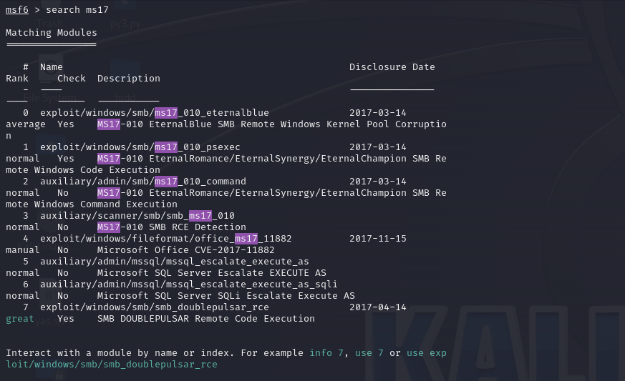

**After seeing that its usable we first set the right host using the “set rhost ip address” and finally use the exploit function. Doing so will give us access to the operating system and the files.**

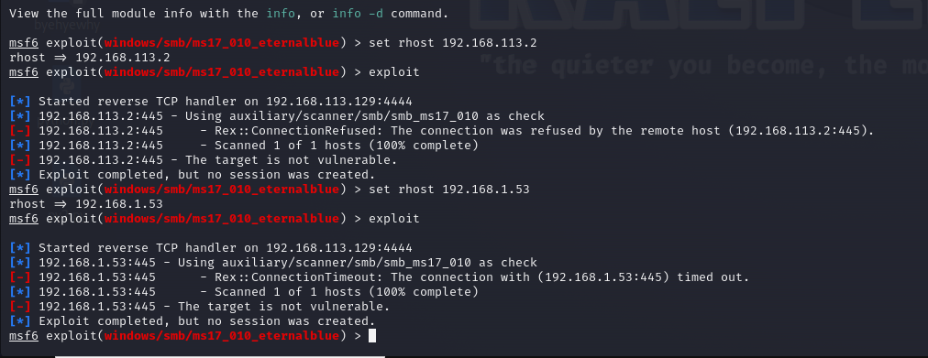

**The only reason I couldn’t gain access was because my system was not windows , but for windows 7 the above code works. And bellow you can see what will happen once you gain access to the system.**

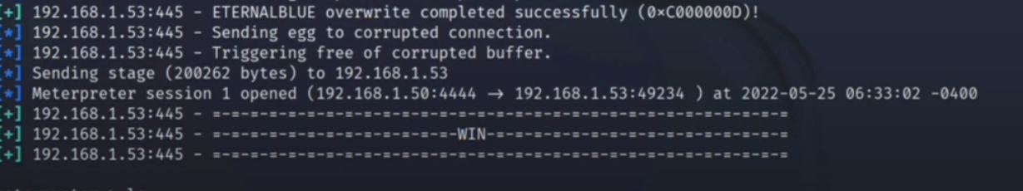

**Using ls you can find the info of files and pwd where you are at the system.**

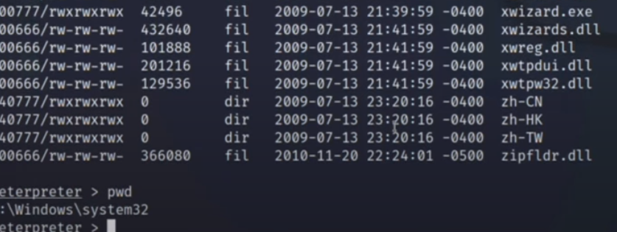

**Note: The link to the video in google drive:**

**https://drive.google.com/file/d/1VomGYCZdQM2bylgs5UvTm8rEG8_Zf2aJ/view?usp=sharing**